Association rules Documentation

Business Problem: Apply Association rule using apriori function

Objective :

1. Try different values of support and confidence.
2. Change different length in apriori function.
3. Visualize the obtain rules using different plots.

About the data:

Groceries data that comes with the arules pkg. Unlike dataframe, using head(Groceries) does not display the transaction items in the data. To view the transactions, use the inspect() function instead.

EDA :

To perform EDA the following packages must be installed, these packages are necessary for all the data sets.

library("arules") # Used for building association rules i.e. apriori algorithm # for visualizing rules

library("arulesViz")

inspect(Groceries[1:10])

summary(Groceries)

Keep changing support and confidence values to obtain different rules

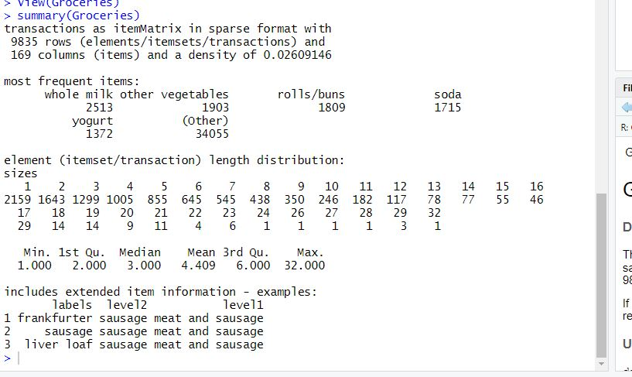

Now Perform Association rule using apriori

rule <- apriori(Groceries,parameter = list(support=0.008, confidence =0.08, minlen=3))

support and confidence of 0.08 with minimum length of 3

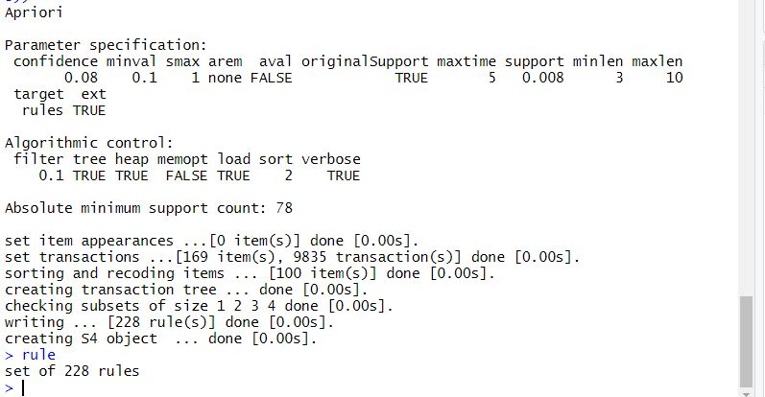

# Overall quality

head(quality(rule))

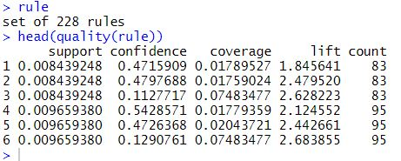

inspect(rule[1:5]) # to view we use inspect

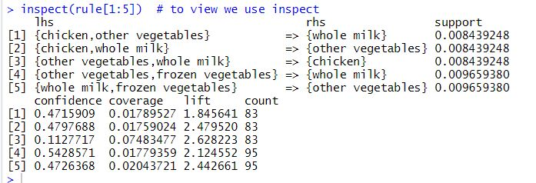

Different Ways of Visualizing Rules

window()

plot(rule,method ="scatterplot")

plot(rule,method = "grouped")

plot(rule,method = "graph")

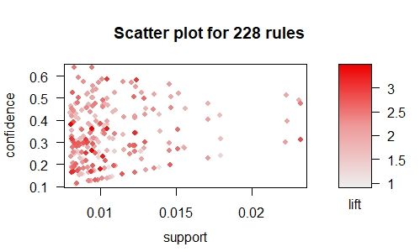

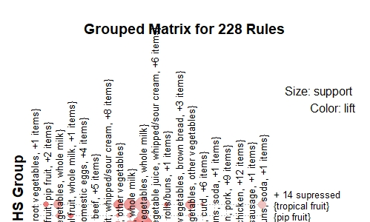

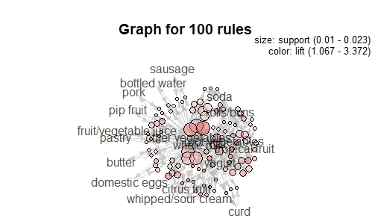

SORTING OF RULE

rule <- sort(rule, by ="lift")

rule

inspect(rule[1:5])

